Application Note

PC to CMMT-XX-EP/MP via Modbus TCP with CMMTt111.dll
This document describe how to use CMMTt111.dll to establish CMMT-AS-...-EP Modbus TCP communication between PC and CMMT-XX-EP/MP CMMT-AS-...-MP with visual studio sample application. CMMT-ST-...-EP
100314

Title ............................................................................ PC to CMMT-XX-EP/MP via Modbus TCP with CMMTt111.dll
Version ............................................................................................................................................................. 1.30
Document no. .............................................................................................................................................. 100314
Original ................................................................................................................................................................ En
Author ............................................................................................................................................................. Festo
Last saved ............................................................................................................................................ 08.08.2022

Copyright Notice
This documentation is the intellectual property of Festo SE & Co. KG, which also has the exclusive copyright. Any modification of the content, duplication or reprinting of this documentation as well as distribution to third parties can only be made with the express consent of Festo SE & Co. KG.
Festo SE & Co KG reserves the right to make modifications to this document in whole or in part. All brand and product names are trademarks or registered trademarks of their respective owners.

Legal Notice
Hardware, software, operating systems and drivers may only be used for the applications described and only in conjunction with components recommended by Festo SE & Co. KG.
Festo SE & Co. KG does not accept any liability for damages arising from the use of any incorrect or incomplete information contained in this documentation or any information missing therefrom.
Defects resulting from the improper handling of devices and modules are excluded from the warranty. The data and information specified in this document should not be used for the implementation of safety functions relating to the protection of personnel and machinery.
No liability is accepted for claims for damages arising from a failure or functional defect. In other respects, the regulations with regard to liability from the terms and conditions of delivery, payment and use of software of Festo SE & Co. KG, which can be found at www.festo.com and can be supplied on request, shall apply. All data contained in this document do not represent guaranteed specifications, particularly with regard to functionality, condition or quality, in the legal sense.
The information in this document serves only as basic information for the implementation of a specific, hypothetical application and is in no way intended as a substitute for the operating instructions of the respective manufacturers and the design and testing of the respective application by the user.
The operating instructions for Festo products can be found at www.festo.com .
Users of this document (application note) must verify that all functions described here also work correctly in the application. By reading this document and adhering to the specifications contained therein, users are also solely responsible for their own application.

© (Festo SE & CO. KG, D-73726 Esslingen, 2022)
Internet: http://www.festo.com

Table of contents

1 Important instruction 4
1.1 Designated use 4
1.2 Components and Software used for test 4
1.3 Topology of the tested system 4
1.4 Recommended manual 4
2 Overview 5
2.1 Process data 5
2.2 Telegram 111 5
2.3 Festo Automation Suite 6
2.3.1 New Project 6
2.3.2 Start first setup 7
2.3.3 Fieldbus 9
2.3.4 Record Table 10
2.3.5 Extended process data 10
3 CMMTt111.dll 11
3.1 Method 11
3.2 Properties 12
4 Implementation example in Visual Studio 2019 17
4.1 Initialisation 17
4.2 Essential parameters 18
4.3 Connect 19
4.4 Gain control 19
4.5 Automatic Control 19
4.6 Jog Control 20
4.7 STW1, POS_STW1 and POS_STW2 direct access 21

Important instruction

Important instruction

Designated use

This application note describes how to use CMMTt111.dll. It is designed to establish Modbus TCP communication between PC and Festo motor controller CMMT-AS-…-EP and CMMT-ST-…-EP based on telegram 111 drive profile.

Components and Software used for test

Type/Name | Version Software/Firmware | Date of manufacture / SN
CMMT-AS-C4-3A-MP-S1 | V031.0.7.10 | 07-2022
EMMB-AS-60-04-S30S | -- | LN
Festo Automation Suite | V2.4.0.442 | --
CMMT-AS Plug-in | 2.4.0.464 | --
Windows 10 | 10.0.19044 Build 19044 | --
CMMTt111.dll | V1.01 | 2022-07-29
Table 1.2: Components/Software used

Topology of the tested system

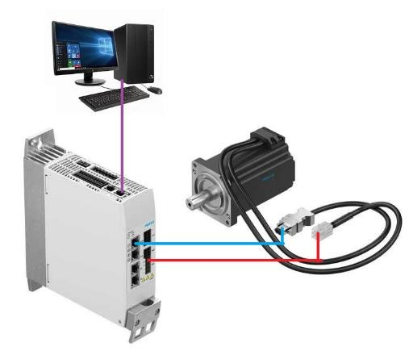
Figure 1.3: Topology of the tested system

Recommended manual

Recommended manual can be found via this link:
https://www.festo.com/net/en_gb/SupportPortal/Downloads/648237/719030/CMMT-AS-SW_manual_202110h_8166934g1.pdf

Alternatively, it can be searched via Festo Online eXperience (FoX) and search for “CMMT-AS-C4-3A-MP”. Link:
https://www.festo.com/my/en/a/8143164/?q=CMMT-AS-C4-3A~:festoSortOrderScored
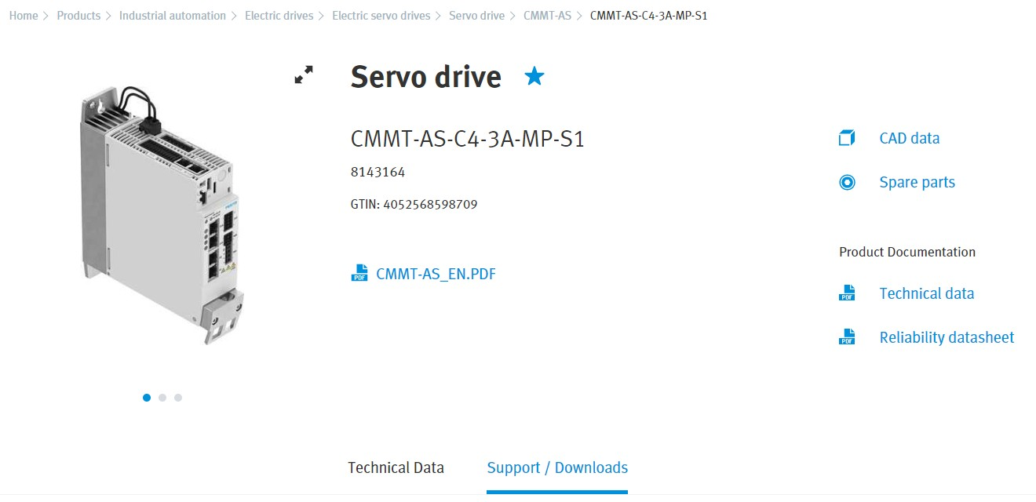

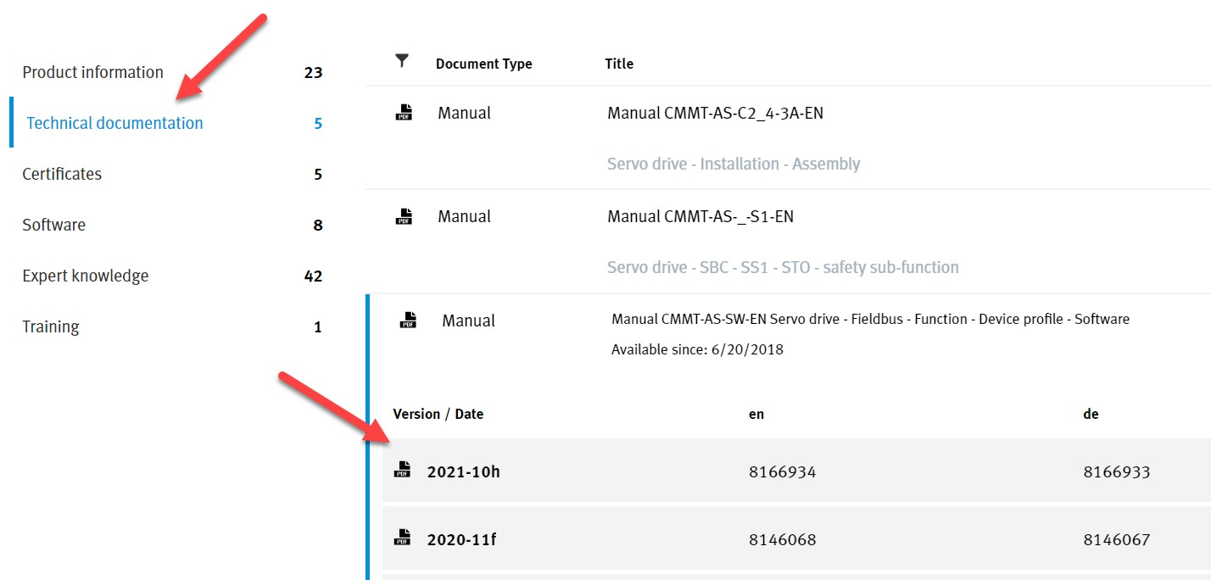

Figure 1.4: Recommended manual

Overview

Process data

The process data for each connection consists of the following:
- 12 Word (24 bytes) of Telegram 111 (PROFIdrive over Modbus TCP)
- Up to 16 Word (32 bytes) of extended process data (FAS feature - optional)

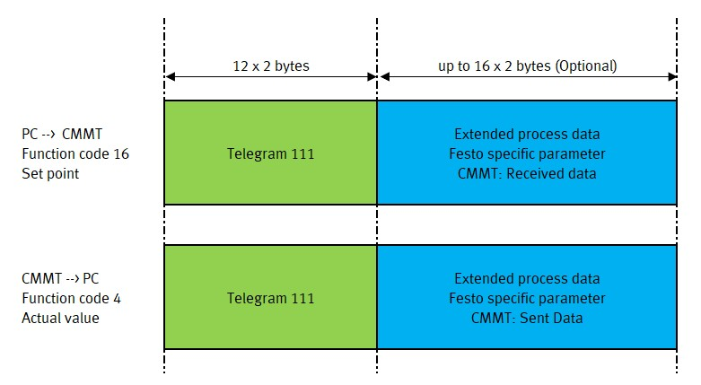
Figure 2.1: Process Data

Telegram 111

Word | Set point | Modbus Address |  | Actual value | Modbus Address
1 | STW1 | 40001 |  | ZSW1 | 30001
2 | POS_STW1 | 40002 |  | POS_ZSW1 | 30002
3 | POS_STW2 | 40003 |  | POS_ZSW2 | 30003
4 | STW2 | 40004 |  | ZSW2 | 30004
5 | OVERRIDE | 40005 |  | MELDW | 30005
6 | MDI_TARPOS1 | 40006 |  | XIST_A1 | 30006
7 | MDI_TARPOS2 | 40007 |  | XIST_A2 | 30007
8 | MDI_VELOCITY1 | 40008 |  | NIST_B1 | 30008
9 | MDI_VELOCITY2 | 40009 |  | NIST_B2 | 30009
10 | MDI_ACC | 40010 |  | FAULT_CODE | 30010
11 | MDI_DEC | 40011 |  | WARN_CODE | 30011
12 | Reserve | 40012 |  | Reserve | 30012
Function code 4: Read Input Register – Read actual value from CMMT
Function code 16: Write Multiple Register – Write set point to CMMT

Table 2.2: Telegram 111 in Modbus TCP

Festo Automation Suite

Important setting in Festo Automation Suite to establish Modbus TCP communication between PC and CMMT.

New Project

Open FAS, create new project:
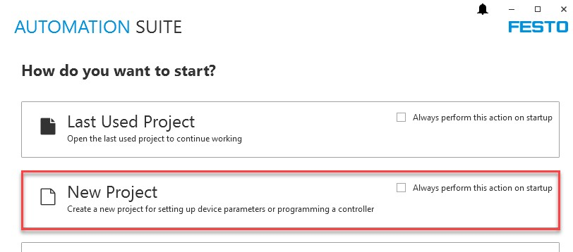
Figure 2.3.1.1: Create New Project

Check FAS version Check Plug in version:
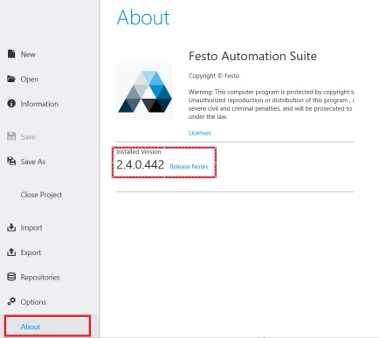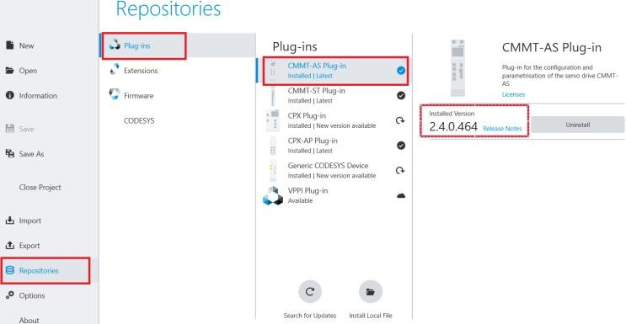

Figure 2.3.1.2: Check FAS version Figure 2.3.1.3: Check Plug in version

Add new CMMT: Open CMMT Plug In:
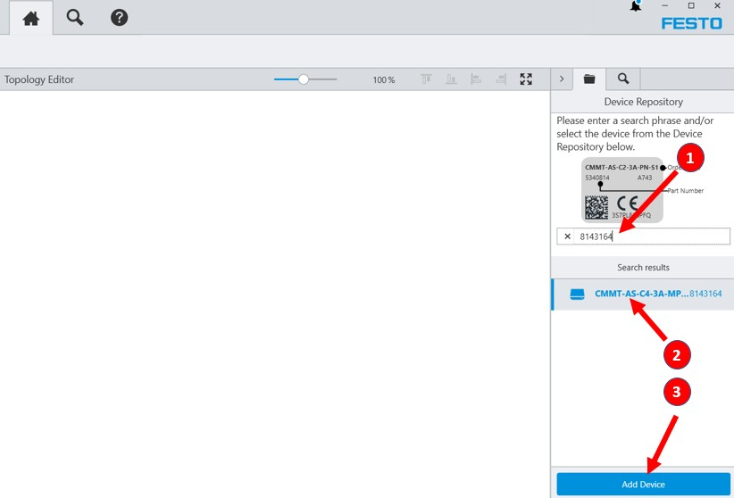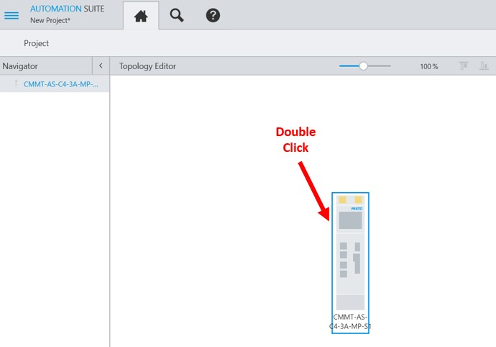

Figure 2.3.1.4: Add new CMMT Figure 2.3.1.5: Open CMMT Plug In

Start first setup

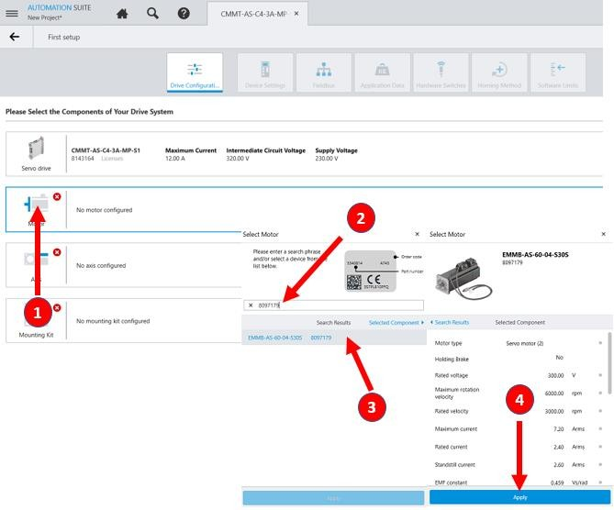
Figure 2.3.2.1: Start first setup

Similar step to add Axis and Mounting Kit:

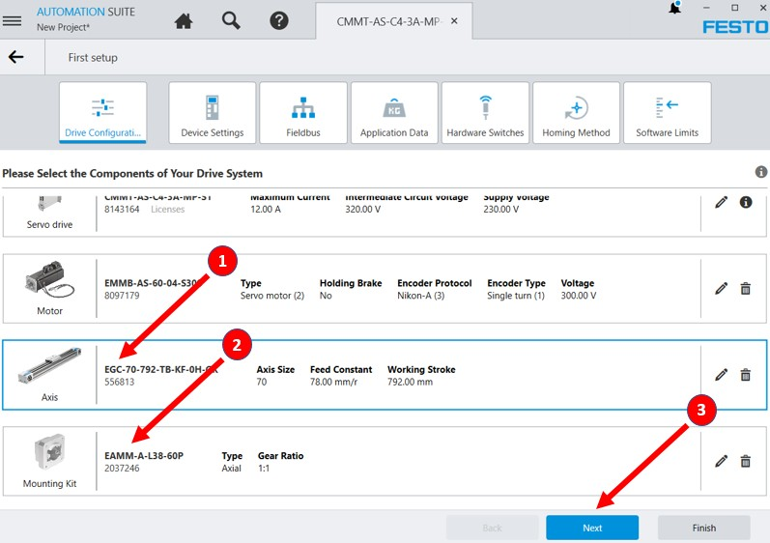
Figure 2.3.2.2: Complete device configuration

Click on “Next” to continue to the next page. On the device setting, select activation via “Fieldbus (2)”.
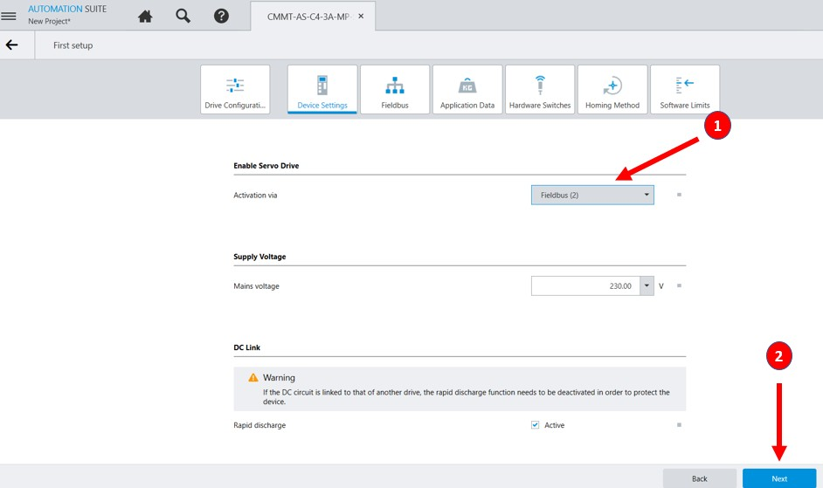
Figure 2.3.2.3: Device settings

On fieldbus configuration, select “Ethernet/IP – ModbusTCP (3)”. On telegram selection, select “Telegram 111” and insert IP Address for Modbus Communication.
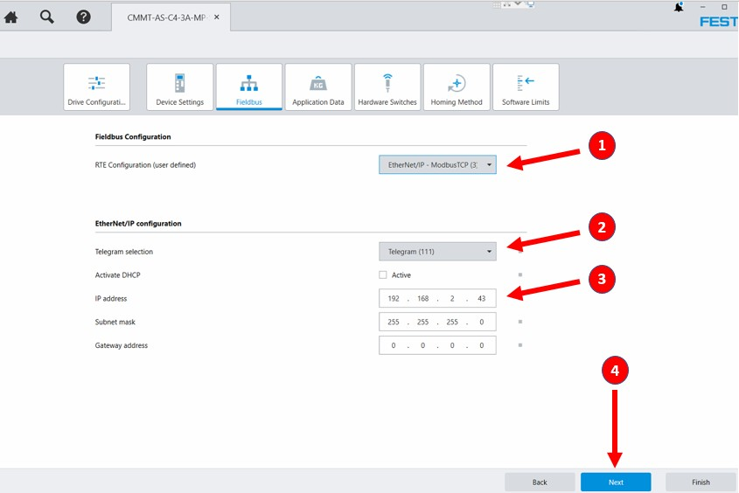
Change as you need in the next setup. Once finish, click on finish.

Figure 2.3.2.4: Finish

Fieldbus

Factor group setting is related to Table 3.7: Group Setting, ConvertPositionInput and ConvertPositionOutput

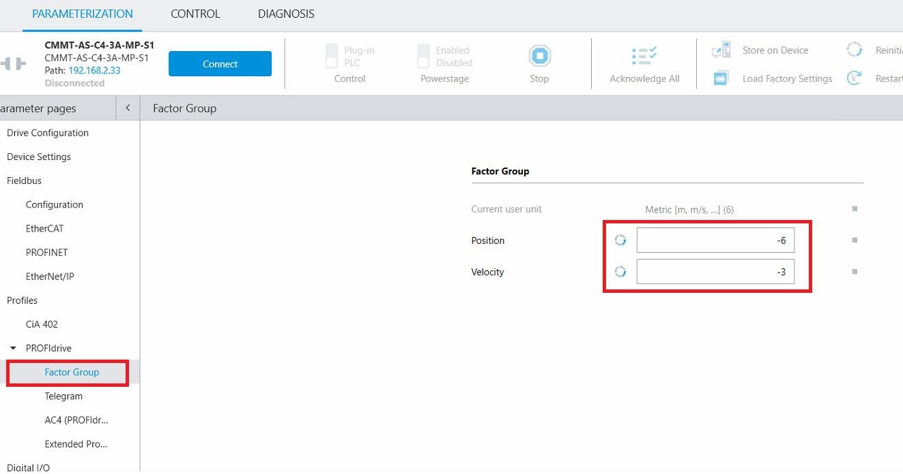
Figure 2.3.3.1: Factor group

This setting is related to Table 3.16: Group output – OutW [] Processed, 100% setting Acceleration and Deceleration resulted value set here. “Base value velocity” value can be used as reference to set ConvertVelocityOutput, see figure 4.1.3.

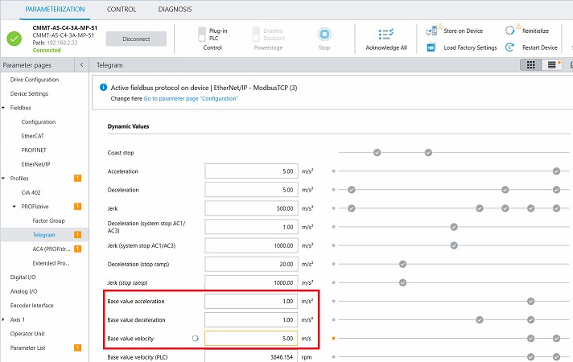
Figure 2.3.3.2: Base value

Record Table

Create record list as below:
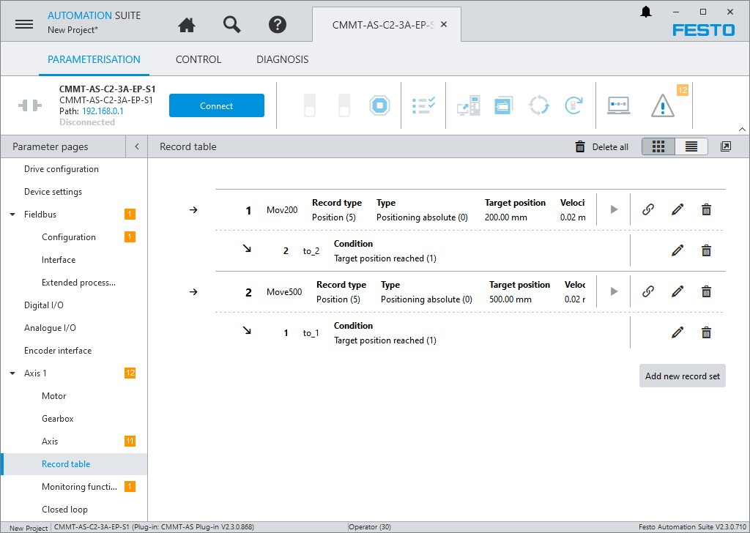
Figure 2.3.4: Record table

Extended process data

Figure below shows how to send and receive record table field 2 (Target position) via extended process data.

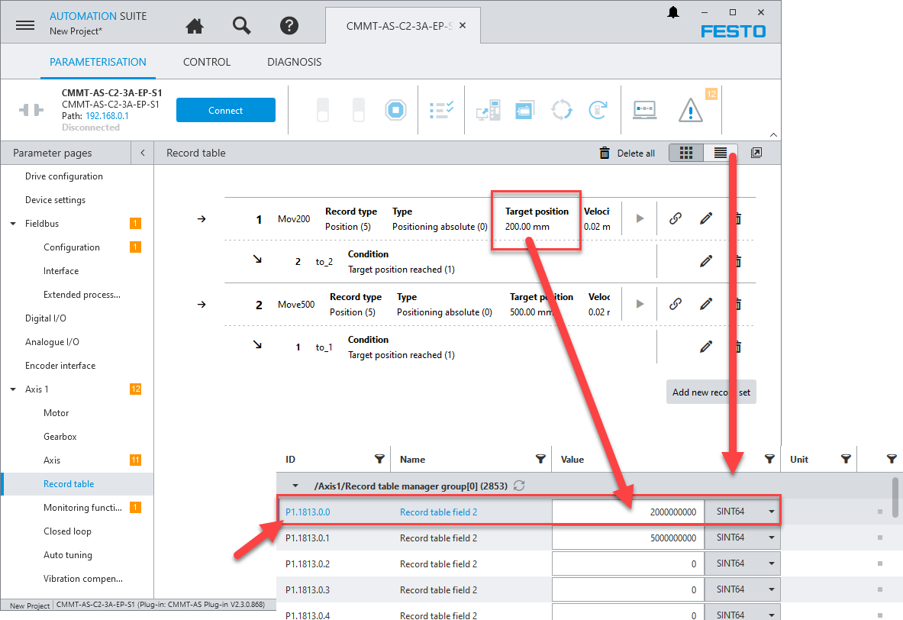
Figure 2.3.5.1: Get parameter number from record table

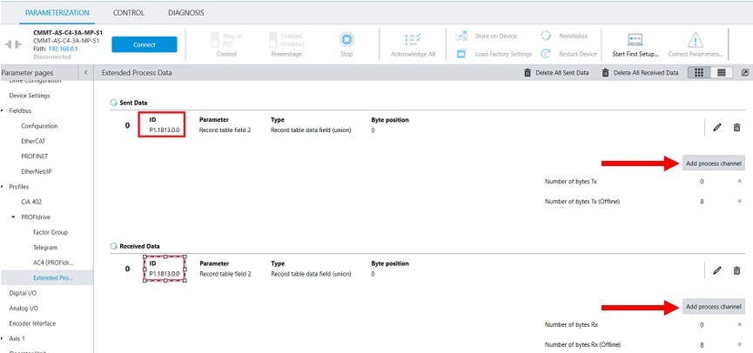
Figure 2.3.5.2: Adding extended process data

The total number of bytes for both send and receive data are 8 bytes which is equivalent with 4 words.

CMMTt111.dll

Method

Method
Namespace | CMMTt111
Class | festoCMMT
Table 3.1: Method

To connect to CMMT via Modbus TCP
Constructor | Connect(string ipAddress, byte IW, byte OW)
ipAddress | IP Address of CMMT-EP
IW | Number of extended process data input in word (16 bit)
OW | Number of extended process data output in word (16 bit)
Port | Default = 502, cannot be changed
Table 3.2: Connect

To disconnect from CMMT

Constructor Disconnect()
Table 3.3: Disconnect  To end thread in CMMTt111.dlll. Must be called | when exit application
Constructor | ExitApplication()
Table 3.4: Disconnect

Automatic control function
String | CmmtControl(byte mode, byte cmd)
mode | 1: homing mode
 | 2: absolute positioning mode
 | 3: relative positioning mode
 | 4: record positioning mode
cmd | 0 --> 1 : execute mode
 | 0 --> 2 : stop movement (halt)
 | 0 --> 3 : clear remaining position
 | 0 --> 4 : acknowledge malfunction and set output stage
String response:
No Output stage enable | !OutputStageEnable & active Cmd != 4
Malfunction, fault/warning: <Fault / Warn code> | Malfunction Effective
Unable to reset malfunction | Timeout during cmd=4
Set Output Stage.. | OutputStageEnable: 0 --> 1
Operation enabled | OperationEnabled
Can't enable operation | Timeout during enabling operation
Operation is not enabled | !OperationEnabled
homing... | Homing start, mode=1, cmd=1
homing time-out | Homing timeout during homing mode
Homing done | Homing success
Homing interrupted | Stop triggered during homing
moving... | Move absolute, mode=2 or mode=3, cmd=1
time-out | Time out during move absolute/relative/record position
Position reached | Move absolute/relative done
Position record selection is not set | PositionRecord == 0
moving to record selection...X | Move record position, mode=4, cmd=1
Position reached: X | Move record position done
Intermediate Stop executed | cmd=2, IntermediateStop=0
Remaining position cleared | IntermediateStop==0 & cmd=3, RejectPositioningTask=0
String response in integer --> check properties icmmtStatus

Table 3.5: CmmtControl

Properties

Properties
Namespace | CMMTt111
Class | festoCMMT
Table 3.6: Properties

Group setting |  | {Get; Set;}
float | ConvertPositionInput | ActualPosition = (XIST_A1 + XIST_A2 * 65536) / ConvertPositionInput
float | ConvertVelocityInput | ActualVelocity = (NIST_B1 + NIST_B2 * 65536) / ConvertVelocityInput
float | ConvertPositionOutput | MDI_TarPos1 = (TargetPosition * ConvertPositionOutput) % 65536
 |  | MDI_TarPos2 = (TargetPosition * ConvertPositionOutput) / 65536;
float | ConvertVelocityOutput | MDI_Velocity1 = (TargetVelocity * ConvertVelocityOutput) % 65536
 |  | MDI_Velocity2 = (TargetVelocity * ConvertVelocityOutput) / 65536;
int | CycleTime = 15 | Cycle time to read and write to CMMT via modbus, 10 = 10 ms
Int | ModbusTimeOut | Modbus time out, 0 ms – 10000 ms
int | Timeout = 0 | Time out during cmd =1 in CMMTControl
 |  | Timeout = 20000 * CycleTime = 200000ms = 200 second
int | Timewait = 5 | Time wait during cmd =1 in CMMTControl
Group setting |  | {Get; Set;}
 |  | Timewait = 5 * CycleTime = 50ms
Int | Homingtimeout = 0 | Homing time out during mode=1, cmd=1 in CMMTControl
 |  | Homingtimeout = 1000 * CycleTime = 10000ms = 10 second
bool | AccessOutputWord_STW1 = false; | True = mentioned Output Word can be modified from code False = mentioned Output Word will follow Output BIT
bool | AccessOutputWord_POS_STW1  = false;
bool | AccessOutputWord_POS_STW2  = false;
Int | SetReadTimeOut | Default = 30ms, minimum 10ms, skip read data from CMMT when time out reached
Int | MaxReadTime | Keep the largest ActualReadTime (ms)
Int | MaxReadmbTime | Keep the largest ActualReadmbTime (ms)
Int | MaxWritembTime | Keep the largest ActualWritembTime (ms)
Int | CounterPass | Count number of ActualReadTime that exceed SetReadTimeOut
Table 3.7: Group Setting

Group status |  | {Get;}
string | Version | = current version and release date
bool | Connected = false; | = True, when connected to CMMT
bool | ConnectionError = false; | = True, if connection disturbed, Connected will still = true
int | iRetryConnection = 0; | increase every cycle time when ConnectionError = true
string | StatusRead = ""; | String response of reading actual value from CMMT
string | StatusWrite = ""; | String response of writing set point to CMMT
string | Status = ""; | connection status in string
 |  | = Connection retry + iRetryConnection
 |  | = Disconnected
 |  | = Retry in 5 sec --> failed more than 3 times with cycle time, retry in 5 sec
 |  | = Connected
 |  | = Can't connect --> check cable, IP address
 |  | = Conversion failed --> check ConvertPositionInput, etc, Overflow?
Int | iCmmtStatus | = integer response of CmmtControl method
 | = 1 | CmmtStatus = "No Output stage enable"
 | = 2 | CmmtStatus = "Malfunction, fault/warning
 | = 405 | CmmtStatus = "Unable to reset malfunction"
 | = 4010 | CmmtStatus = "Set Output Stage.."
 | = 40301 | CmmtStatus = "Operation enabled"
 | = 40302 | CmmtStatus = "Can't enable operation"
 | = 1101 | CmmtStatus = "Operation is not enabled"
 | = 1102 | CmmtStatus = "homing..."
 | = 11201 | CmmtStatus = "homing time-out"
 | = 11202 | CmmtStatus = "Homing done"
 | = 11203 | CmmtStatus = “Homing interrupted”
 | = 150 | CmmtStatus = "Operation is not enabled"
 | = 1510 | CmmtStatus = "time-out"
 | = 15301 | CmmtStatus = "time-out"
 | = 15302 | CmmtStatus = "Position reached"
 | = 15303 | CmmtStatus = "moving..."
 | = 1401 | CmmtStatus = "Operation is not enabled"
 | = 1402 | CmmtStatus = "Position record selection is not set"
 | = 1410 | CmmtStatus = "time-out"
 | = 14301 | CmmtStatus = "time-out"
 | = 14302 | CmmtStatus = "Selection reached: "
 | = 14303 | CmmtStatus = "moving to record selection..."
 | = 21 | CmmtStatus = "Intermediate Stop executed"
 | = 31 | CmmtStatus = "Remaining position cleared"
Int | ActualReadTime | To monitor actual read time (ms)
Int | ActualReadmbTime | To monitor actual read cycle time (ms)
Group status |  | {Get;}
Int | ActualWritembTime | To monitor actual write cycle time (ms)
Table 3.8: Group Status

Group input – InW [] |  | {Get;}
int | ZSW1 | = InW[0]
int | POS_ZSW1 | = InW[1]
int | POS_ZSW2 | = InW[2]
int | ZSW2 | = InW[3]
int | MELDW | = InW[4]
int | XIST_A1 | = InW[5]
int | XIST_A2 | = InW[6]
int | NIST_B1 | = InW[7]
int | NIST_B2 | = InW[8]
int | Fault_Code | = InW[9]
int | Warn_Code | = InW[10]
int |  | = InW[11]
Table 3.9: Group input – InW []

Group input – InW [] Processed |  | {Get;}
float | ActualPosition | ➔ properties group setting ConvertPositionInput
float | ActualVelocity | ➔ properties group setting ConvertVelocityInput
Table 3.10: Group input – InW [] Processed

Group input bit – ZSW1 |  | {Get;}
bool | ReadytobeSwitchOn | = InW[0].0
bool | ReadyforOperation | = InW[0].1
bool | OperationEnabled | = InW[0].2
bool | MalfunctionEffective | = InW[0].3
bool | CoastingActive (NC) | = InW[0].4
bool | FastStopActive (NC) | = InW[0].5
bool | SwitchOnLockActive | = InW[0].6
bool | WarningEffective | = InW[0].7
bool | PositionInRange | = InW[0].8
bool | GuideRequired | = InW[0].9
bool | ReadyforOperation | = InW[0].10
bool | ReferencePointSet | = InW[0].11
bool | PositioningTaskActivated | = InW[0].12
bool | DriveStationary | = InW[0].13
bool | AxisAccelerated | = InW[0].14
bool | DriveDecelerated | = InW[0].15
Table 3.11: Group Input bit – ZSW1

Group input bit – POS_ZSW1 |  | {Get;}
bool | ActivePositioningRecordBit0 | = InW[1].0
bool | ActivePositioningRecordBit1 | = InW[1].1
bool | ActivePositioningRecordBit2 | = InW[1].2
bool | ActivePositioningRecordBit3 | = InW[1].3
bool | ActivePositioningRecordBit4 | = InW[1].4
bool | ActivePositioningRecordBit5 | = InW[1].5
bool | ActivePositioningRecordBit6 | = InW[1].6
bool |  | = InW[1].7
Group input bit – POS_ZSW1 |  | {Get;}
bool | NegativeLimitSwitchActive | = InW[1].8
bool | PositiveLimitSwitchActive | = InW[1].9
bool | JoggingActive | = InW[1].10
bool | HomingActive | = InW[1].11
bool |  | = InW[1].12
bool | PositioningRecordActive | = InW[1].13
bool |  | = InW[1].14
bool | MDIActive | = InW[1].15
Table 3.13: Group Input bit – POS_ZSW1

Group input bit – POS_ZSW1 Processed |  | {Get;}
byte | ActivePositioningRecord | Active positioning record in byte
Table 3.14: Group Input bit – POS_ZSW1 Processed

Group input bit – POS_ZSW2 |  | {Get;}
bool | TrackingModeActive | = InW[2].0
bool | VelocityLimitingActive | = InW[2].1
bool | SetPointValueStopped | = InW[2].2
bool |  | = InW[2].3
bool | DriveTravelsForward | = InW[2].4
bool | DriveTravelsBackward | = InW[2].5
bool | NegativeSoftwareLimitSwitchActive | = InW[2].6
bool | PositiveSoftwareLimitSwitchActive | = InW[2].7
bool | ActualPositionLessEqualThanCamSwitch0 | = InW[2].8
bool | ActualPositionLessEqualThanCamSwitch1 | = InW[2].9
bool | DirectOutput1ViaPositioningRecord | = InW[2].10
bool | DirectOutput2ViaPositioningRecord | = InW[2].11
bool | FixedStopReached | = InW[2].12
bool | FixedStopClampingTorqueReached | = InW[2].13
bool | TravelToFixedStopActive | = InW[2].14
bool | PositionCommandActive | = InW[2].15
Table 3.15: Group Input bit – POS_ZSW1

Group output – OutW [] |  | {Get; Set;}
int | STW1 | OutW[0] = STW1 = Group output bit STW1  ➔ Properties group setting, AccessOutputWord_STW1 = False
int | POS_STW1 | OutW[1] = POS_STW1 = Group output bit POS_STW1  ➔ Properties group setting, AccessOutputWord_POS_STW1 = False
int | POS_STW2 | OutW[2] = POS_STW2 = Group output bit POS_STW2  ➔ Properties group setting, AccessOutputWord_POS_STW2 = False
int | STW2 | OutW[3] = STW2
int | iOverride | OutW[4] = iOverride
int | MDI_TarPos1 | OutW[5] = MDI_TarPos1
int | MDI_TarPos2 | OutW[6] = MDI_TarPos2
int | MDI_Velocity1 | OutW[7] = MDI_Velocity1
int | MDI_Velocity2 | OutW[8] = MDI_Velocity2
int | MDI_ACC | OutW[9] = MDI_ACC
Group output – OutW [] |  | {Get; Set;}
int | MDI_DEC | OutW[10] = MDI_DEC
int |  | OutW[11]
Table 3.16: Group output – OutW []

Group output – OutW [] Processed |  | {Get; Set;}
float | Override | iOverride = (Override * 16384) / 100
float | TargetPosition | MDI_TarPos1 = (TargetPosition * ConvertPositionOutput) % 65536 MDI_TarPos2 = (TargetPosition * ConvertPositionOutput) / 65536
float | TargetVelocity | MDI_Velocity1 = (TargetVelocity * ConvertVelocityOutput) % 65536 MDI_Velocity2 = (TargetVelocity * ConvertVelocityOutput) / 65536
float | Acceleration | MDI_ACC = (Acceleration * 16384) / 100
float | Deceleration | MDI_DEC = (Deceleration * 16384) / 100;
Table 3.17: Group output – OutW [] Processed

Group output bit – STW1 |  | {Get; Set;}
bool | OutputStageEnable | OutW[0].0
bool | DriveCoast | OutW[0].1
bool | FastStop | OutW[0].2
bool | EnableOperation | OutW[0].3
bool | RejectPositioningTask (NC) | OutW[0].4
bool | IntermediateStop (NC) | OutW[0].5
bool | ActivePositioningTask | OutW[0].6
bool | AcknowledgeMalfunction | OutW[0].7
bool | Jogging1 | OutW[0].8
bool | Jogging2 | OutW[0].9
bool | PLCMastedControl | OutW[0].10
bool | StartHoming | OutW[0].11
bool | ReleaseHonfingBrake | OutW[0].12
bool |  | OutW[0].13
bool |  | OutW[0].14
bool |  | OutW[0].15
Table 3.18: Group output bit – STW1

Group output bit – POS_STW1 |  | {Get; Set;}
bool | PositioningRecordSelectionBit0 | OutW[1].0
bool | PositioningRecordSelectionBit1 | OutW[1].1
bool | PositioningRecordSelectionBit2 | OutW[1].2
bool | PositioningRecordSelectionBit3 | OutW[1].3
bool | PositioningRecordSelectionBit4 | OutW[1].4
bool | PositioningRecordSelectionBit5 | OutW[1].5
bool |  | OutW[1].6
bool | RelativePositioning | OutW[1].7 = 0
bool | AbsolutePositioning | OutW[1].7 = 1
bool |  | OutW[1].8
bool |  | OutW[1].9
bool |  | OutW[1].10
bool |  | OutW[1].11
bool |  | OutW[1].12
bool |  | OutW[1].13
bool |  | OutW[1].14
bool | MDISelection | OutW[1].15

Table 3.20: Group output bit – POS_STW1

Group output bit – POS_STW2 |  | {Get; Set;}
bool | TrackingMode | OutW[2].0
bool | CurrentPositionasHome | OutW[2].1
bool |  | OutW[2].2
bool |  | OutW[2].3
bool |  | OutW[2].4
bool | IncrementalJogging | OutW[2].5
bool |  | OutW[2].6
bool |  | OutW[2].7
bool |  | OutW[2].8
bool |  | OutW[2].9
bool | TouchProbeSource | OutW[2].10
bool | TouchProbeEdge | OutW[2].11
bool |  | OutW[2].12
bool |  | OutW[2].13
bool | ActivateSoftwareLimitSwitch | OutW[2].14
bool | ActivateHardwareLimitSwitch | OutW[2].15
Table 3.21: Group output bit – POS_STW2

Implementation example in Visual Studio 2019

Initialisation

Add “using CMMTt111”

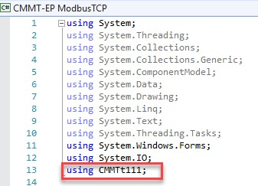
Figure 4.1.1: using CMMTt111

Declare class festoCMMT:

festoCMMT = new festoCMMT();

Implementation example:
Implementation example in Visual Studio 2019

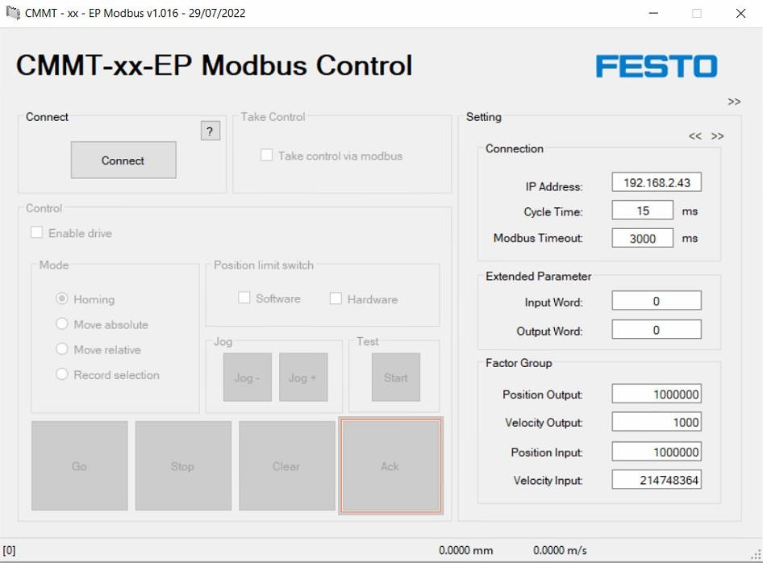
Figure 4.1.2: Implementation example

How to set position and velocity input output is by clicking on the “?” button to open help menu. Fill up the FAS factor Group and FAS Reference values (Section 2.3.4 - Fieldbus) as shown below. The value in “Factor Group” can be copy and paste manually from help menu to main interface.

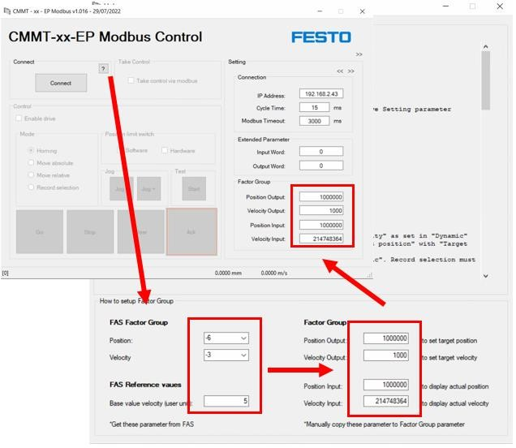
Figure 4.1.3: Setting factor group

Essential parameters

Before Connect, it is essential to set below parameters:

// essential setting // cycle time
festoCMMT.CycleTime = 15; // 15 ms
// modbus time out festoCMMT.ModbusTimeOut = 1000; // 500 ms
// read time out festoCMMT.ReadTimeOut = 100; // 100 ms // Conversion & dynamic - See page 9 ------------------------------------------
// Conversion
festoCMMT.ConvertPositionOutput = 1000000; | // Factor group, position = -6
festoCMMT.ConvertVelocityOutput = 1000; | // Factor group, velocity = -3
festoCMMT.ConvertPositionInput = 1000000; | // Factor group, position = -6
festoCMMT.ConvertVelocityInput = 214748364; | // Reference value, base value
 | // velocity = 5
// dynamic
festoCMMT.Acceleration = 100; // 100% of reference value, base value acceleration festoCMMT.Deceleration = 100; // 100% of reverence value, base value deceleration
// ----------------------------------------------------------------------------
// time out
festoCMMT.Timeout = 0; // no time out, Command abort when reach time out festoCMMT.Homingtimeout = 1000; // 1000 x cycle time = 20 sec homing time out festoCMMT.Timewait = 5; //5 * cycle time = 100ms, Wait before check next condition
// Activate software and hardware limit festoCMMT.ActivateHardwareLimitSwitch = true; festoCMMT.ActivateSoftwareLimitSwitch = true;

Connect

Command to establish communication between PC and CMMT:

string IPAddress = “192.168.2.44” // example IP Address int ExtendedIW = 4 // (Word) Extended process data in – int 16 bit int ExtendedOW = 4 // (Word) Extended process data out – int 16 bit
ExtendedIW and ExtendedOW above are set based on setting in chapter 2.3.5 Extended process data.
festoCMMT.Connect(IPAddress, ExtendedIW, ExtendedOW);

Response:
festoCMMT.Connected
= True --> Connected
= False --> Not connected

Gain control

To gain control from PC ad obtain ready to be switched on:
festoCMMT.PLCMasterControl = true;
festoCMMT.EnableOperation = true; festoCMMT.FastStop = true; festoCMMT.DriveCoast = true;

Response:
festoCMMT.ReadytobeSwitchedOn == true;

Automatic Control

Parameter to set before automatic control:

// override festoCMMT.Override = 100.0F; // 100%, 0% to 199%
// Target
festoCMMT.TargetPosition = 10.5F; // in user unit, ex: 10.5 rev festoCMMT.TargetVelocity = 5.0F; // in user unit, ex: 5.0 rev/sec
// Record position festoCMMT.PositioningRecord = 1; // FAS record list = 1

CmmtControl:
// Choose 1 Mode
Mode = 1; // Homing mode
// Mode = 2; // Absolute positioning mode
// Mode = 3; // Relative positioning mode
// Mode = 4; // Record positioning mode
Implementation example in Visual Studio 2019

// Choose 1 Cmd
// Cmd = 1; | // Execute Mode
// Cmd = 2; | // Stop movement (halt)
// Cmd = 3; | // Clear remaining position
Cmd = 4; | // Acknowledge malfunction and set output stage

festoCMMT.CmmtControl(Mode, Cmd); // Define Mode and Cmd before execute
Cmd = 0; // Immediately set Cmd to 0

Example sequence:
- Acknowledge malfunction and set output stage o Mode = X Mode = 1 o Cmd = 4 Cmd = 4
- Obtain homing
  - Mode = 1 Mode = 1 o Cmd = 1 Cmd = 1
- Absolute positioning mode
  - Set override festoCMMT.Override o Set Target position festoCMMT.TargetPosition o Set Target velocity festoCMMT.TargetVelocity
  - Mode = 2 Mode = 2 o Cmd = 1 Cmd = 1
- Relative positioning mode
  - Set override festoCMMT.Override o Set Target position festoCMMT.TargetPosition o Set Target velocity festoCMMT.TargetVelocity
  - Mode = 3 Mode = 3
  - Cmd = 1 Cmd = 1
- Stop during move relative
  - Mode = X Mode = 3
  - Cmd = 2 Cmd = 2
- Continue relative positioning mode
 | o Mode = 3 | Mode = 3
 | o Cmd = 1 | Cmd = 1
• | Stop during move relative
 | o Mode = X | Mode = 3
 | o Cmd = 2 | Cmd = 2
• | Clear remaining position
 | o Mode = X | Mode = 3
 | o Cmd = 3 | Cmd = 3
• | Record positioning mode
 | o Set override | festoCMMT.Override
 | o Set Positioning record | festoCMMT.PositioningRecord
 | o Mode = 4 | Mode = 4
 | o Cmd = 1 | Cmd = 1

Actual position and actual velocity can be monitored (Table 3.10: Group input – InW [] Processed):
festoCMMT.ActualPosition festoCMMT.ActualVelocity
Status:
String feedback from festoCMMT.CmmtControl can be seen in Table 3.5 CmmtControl (String response). Integer feedback can be seen in Table 3.8 Group status (iCmmtStatus).

Jog Control

To Jog, homing must be obtained by observing parameter festoCMMT.ReferencePointSet (== true is homed/referenced).

Example:
Jog- : festoCMMT.Jog1 = true; festoCMMT.Jog2 = false;
Jog+ : festoCMMT.Jog2 = true;
festoCMMT.Jog1 = false;

Response while jog- or jog+ is true:
festoCMMT.JoggingActive == true;

STW1, POS_STW1 and POS_STW2 direct access

Output STW1, POS_STW1 and POS_STW2 are manipulated by accessing Output bit listed in Table 3.18 – Table 3.21. Those output can also be access directly by activating these parameter:

festoCMMT.AccessOutputWord_STW1 = true; festoCMMT.AccessOutputWord_POS_STW1 = true; festoCMMT.AccessOutputWord_POS_STW2 = true;

After enabling above parameters, STW1, POS_STW1 and POS_STW2 listed in Group Output, Table 3.16, can be directly manipulated.

Example:
to set festoCMMT.PLCMasterControl = true; (OutW[0].10, Table 3.18 - Group output bit – STW1) Direct access:
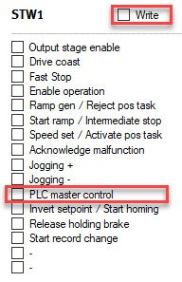
festoCMMT.AccessOutputWord_STW1 = true;
festoCMMT.STW1 = 1024;

